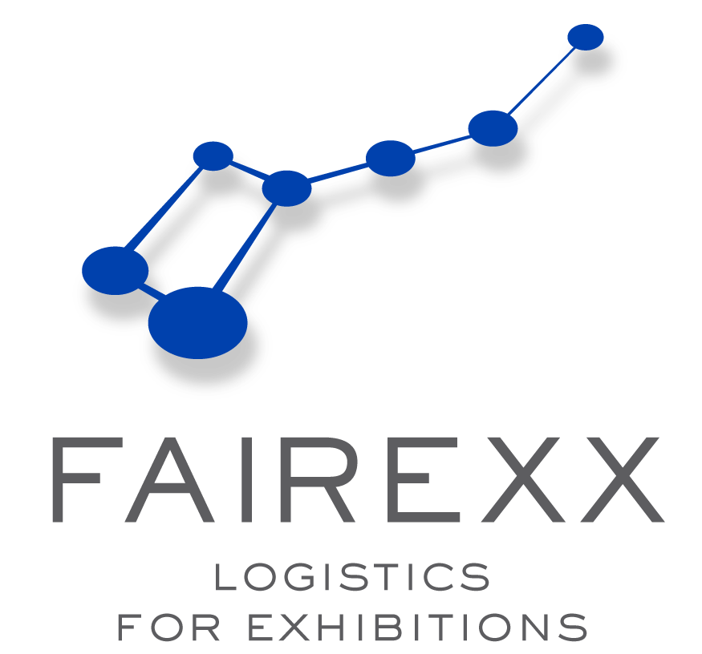

EUROPEAN SOCIETY OF CARDIOLOGY

- VIENNA / AUSTRIA -

01 – 07 September 2007

SHIPPING MANUAL

Consigning of shipments & Deadline dates

Your shipments should arrive at Vienna airport (VIE) not later than
4 working days before desired delivery to booth

- Consignee Adress: FAIREXX Logistics
c/o Schenker & Co AG
Fairs & Exhibitions
Taborstrasse 95
A - 1200 Vienna / Austria

ctc.: Mr. Wolfgang Unzeitig
FON : 0043-5 7686 211 522

Notify : ESC 2007 / Exhibitors Name
Hall / Stand Number

Please send your shipments prepaid, on own Masterairwaybill, consigned to above mentioned adress.
3 original Invoices should be attached to the Airwaybill.

Pre-advices please send to us at least two days before arrival in Barcelona
by Telefax: +49 (0) 30 44 03 47 79
  - Copy of Airwaybill / Flight details
  - Copy of invoice / packing list



Airfreight

Groupage shipments
should arrive at our onsite warehouse - NOT BEFORE 15.08.2007 ! !
(if goods need to be sent before this deadline pls do contact us in advance !!)

latest Arrival of goods 4 working days before desired delivery to booth to the address as follows :

- warehouse adress: Messegelände Wien
c/o FAIREXX Messelager ESC Congress
Südportalstrasse Haupteingang Süd / Halle 1
1020 Vienna / Austria

Notify : ESC 2007 / Exhibitors Name
Hall / Stand Number

Full Trailer Loads
should arrive directly at Fairground Vienna, in accordance with
the official Build-Up Dates and Times.

- fairground Adress: Messegelände Wien
c/o FAIREXX Logistics
Südportalstrasse Haupteingang Süd / Halle 1
1020 Vienna / Austria

Notify : ESC 2007 / Exhibitors Name
Hall / Stand Number

Pre-advices : for your Roadcargo Shipments please send to us in advance
by Telefax: +49 (0) 30 44 03 47 79
    - Trucking details (Truck no., haulier, ETA)
    - Copy of invoice / packing list



Roadfreight

Case Marking
All your Packages should be clearly marked as follows:

- Name of Exhibitor
- ESC 2007
- Hall and Stand number
FAIREXX c/o

1 of .... / 2 of ... / 3 of ... etc.

We kindly ask you to use save and strong packing material
which is strong enough to be re-used after the show.


Documentation required for Customs Clearance

For shipments outside of the EC , we require the following
Documents for the customs clearance:

- 3 Originals of Proforma Invoice / packing List in English, showing : No. of units / weights / sizes / total no. of boxes / values / full description of items in English
- seperate Invoices for Temporary Importation (Exhibits)
and Permanent Importation (consumables, advertisings

Invoices must be addressed to :

FAIREXX Logistics
c/o Schenker & Co AG
Fairs & Exhibitions
Taborstrasse 95
A - 1200 Vienna / Austria

Notify : ESC 2007 / Name of Exhibitor / Hall & Booth No.

- if necessary: Certificat of Origin (Form A / EUR.1)
- if necessary: Special certificates (health / veterinary)

All exhibits / material entered under temporary importation are subject to control and examination by Spain customs for Inward and Outward movements.
Any Exhibit remaining in Spain or the EU after closure of the Exhibition are subject to Duties and / or Taxes. Payments must be guaranteed prior to removal of goods from the Exhibition venue.

Please send a full pre-advice at least one day before arrival to:
Fax : ++49 - 30 44 03 47 79 , attn. Sandra Günther
e-mail: sandra.guenther@fairexx.de

Customs Clearance

Courier
We strongly recommend Exhibitors not to send Courier shipments direct to your stand unless you have a member of your staff present to receive them.
If you do send goods by courier we suggest that you send them to our
warehouse-adress mentioned under Roadfreight.
For shipments sent directly to the stand no liability is accepted.

Insurance

We strongly recommend that all exhibitors arrange Insurance cover to include Transit to and from the exhibition, whilst on display and in storage.

Please contact us for further information and rates.

Further information

Late arrival surcharges

Any shipments arriving after our deadlines that require Customs clearance will be subject to a late arrival surcharge of 25% on our
official handling tariff.

Please note following methods of payment accepted :

- Bank Transfer : pls provide a copy of the Transfer Statement

- Credit Card : pls inform us of your card detaills in advance
(not for customs expenditures unless with an additional 50 % service fee !)

- Cash : all major currencies accepted

Payment

Basic Conditions of Contract

- All work undertaken is subject to the German Forwarders terms and conditions ADSp, newest edition and the SLVS - liability policy, in conjunction with the conditions and rates for trade fair transportation.

- All special transport and crane services are based upon the „Basic conditions of contract for special transport and crane services - BSK“ latest edition.

- The liability of FAIREXX Logistics for Exhibitions GmbH as Fairs & Exhibitions Forwarder, ceases with deposit and restarts with collection of the freight at the exhibition stand, unconsidered of the exhibitors absence at the stand, irrespective of the submission of waybills at the exhibition forwarding agent’s office. Place of jurisdiction AG Gelsenkirchen- Buer for both sides.

- Our invoices will be due immediately after issuance without any further notice according to ADSp. Customers not known to us or with whom we have not agreed any terms of payment, will be asked to pay our expenses before the event starts or on-site during the event or before return shipping of their exhibits.



Basic Conditions

Please Contact our Office:

All Pre-advices should kindly be sent 3 days prior to the arrival dates in Barcelona by Telefax or email to :

FAIREXX GmbH
Marienstrasse 28
12207 Berlin
Germany

FAX : ++49 (0)30 44 03 47 79

Sandra Guenther
TEL : ++49 (0)30 44 03 47 12
email : sandra.guenther@fairexx.de

Marco Junghans
TEL : ++49 (0)30 44 03 47 11
email : marco.junghans@fairexx.de



Contact Details

