ESC Congress 2007
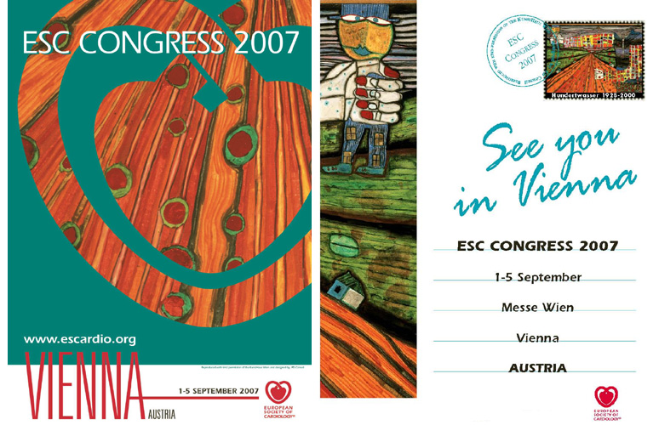
Exhibitor Information
Deadline 2 May 2007

Company & Product Descriptions

Complete your company address & descriptive text as you would like to see it appear in official publications e.g:
- Online at www.escardio.org for company & product descriptions and the
- Event Final Programme & other documents for your company name & address.
Note the description is limited to 150 words format is plain / bold text.
Company name & stand number will be wholly capitalised, other lines in sentence case.

COMPANY NAME*

STAND NUMBER

Address Line 1
Address Line 2
Postcode & City
Country

Tel: + (Intnl. dialing code) / Fax: + (Intnl. dialing code)

Email: Web: (url here)

Company & Product Description (150 words max, no special characters except ®, © and ™)

*Please note that the company name provided on this form will appear on all printed and digital media.

ESC Congress 2007
Exhibitor Information
Deadline 2 May 2007
NEW this year!

Add you company logo to the Virtual Exhibition Map Listing
Price is €1,000

Yes* No

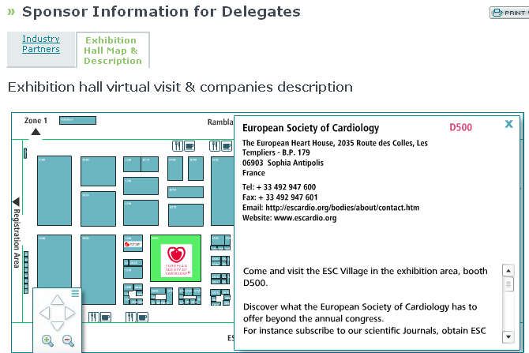

*Please email the logo files to exhibition@escardio.org in 2 sizes (one for listing, one for detailed description).
- large logo: 100x100 pixel (logo centered)
- small logo: 100x20 pixel (logo centered)

Thank you for sending this completed form to

exhibition@escardio.org

To see other important dates, get a copy of the Guidelines for Industry Participation or download technical information, order forms & hall plans, follow this link:
http://www.escexhibition.org/Vienna07/default.aspx

