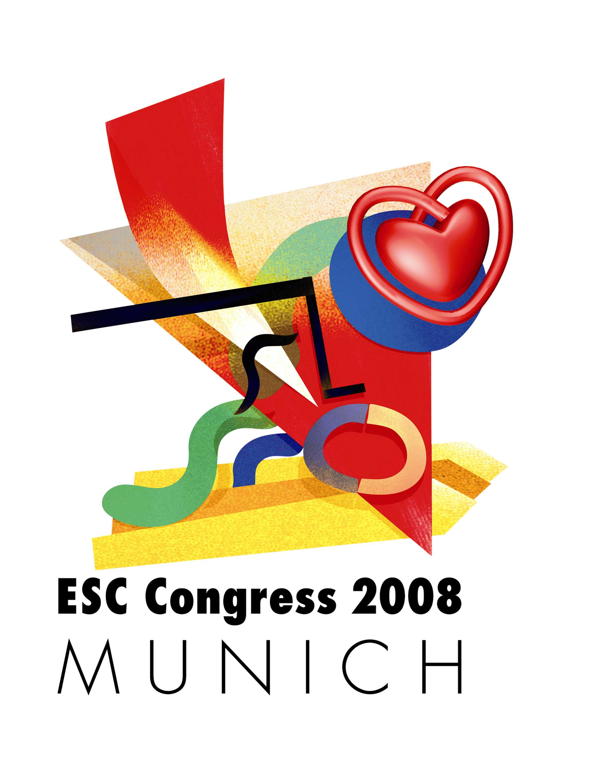
INDUSTRY SPONSORED SESSIONS APPLICATION FORM

SATELLITE SYMPOSIUM WORKSHOP SESSION CLOSED INDUSTRY MEETING FUNCTION SPACE

ORGANISING COMPANY (Indicate the name you wish to appear in the FINAL PROGRAMME and any other publications)
Company Name MANDATORY: |  |  |  |  |  | Contact Person:
Address:
Postal code: | City: |  |  |  |  |  | Country:
Tel: | Fax: |  |  |  | Email:
APPOINTED AGENCY (if applicable)
Agency Name: |  |  |  | Contact Person:
Address:
Postal code: |  |  | City: |  |  |  |  | Country:
Tel: |  |  | Fax: |  |  |  |  | Email:
INVOICING DATA (Please verify this is the correct invoicing address) if different from above address – MANDATORY
Company Name: |  |  |  |  |  | Contact Person:
Invoicing Address: |  |  |  | VAT N° MANDATORY:
 |  |  |  | PO N° MANDATORY:
Postal code: |  | City (& state, if applicable): |  |  |  |  |  |  | Country:
Tel: |  |  | Fax |  |  |  |  | Email:
Payment will be made by bank transfer (details will be provided on the invoice)
Organising Company
Applications for all congress activity must be submitted by the company under whose name each activity is to be organised. We would like to draw your attention to the fact that the correspondence for the above items should be made exclusively between this company and the ESC. The company is responsible for communicating any relevant documents to its staff and appointed agencies.
Appointed Agency
Companies should inform the ESC, in writing, what agency is appointed for which congress activity. Otherwise no requests from agencies will be taken into consideration. This appointed agency cannot fully act as if it were the company itself and the company will continue to be held entirely responsible and accountable for activities organised in its name. It is not the role of any given agency to make initial enquiries or reservations with the ESC independently of the company.
We accept the contract terms & conditions and agree to abide by the regulations & conditions laid down for this event. I am authorised to sign this form on behalf of the applicant/Company.
Date: | Contact Name:

Signature MANDATORY
here

“Disclosure of Information and Marketing. The ESC complies with EC directives, and is registered under the data protection laws in France, and takes all reasonable care to prevent any unauthorised access to your personal data. Our ESC staff and contractors have a responsibility to keep your information confidential. The ESC does not sell, trade, or rent your personal information to others. We may supply your information to trusted ESC contractors to perform specific services. Otherwise, we do not disclose personal information to any other person or organisation without your consent. If you are a delegate at an ESC organised Congress or meeting, when you visit exhibiting company stands, presenting your badge may enable them to retrieve the following personal data: first name(s), last name(s), address, telephone, fax, email, and professional activity information."

SATELLITE SYMPOSIUM (submit one form per Satellite Symposium)
Sessions organised by pharmaceutical & technical industries in cooperation between clinicians and researchers, as part of the congress programme.
DEADLINE: 16 NOVEMBER 2007
Proposed title:
Duration: 90 minutes 180 minutes
Preference date: | Saturday 30 August 2008  12:00 – 13:30 14:00 – 15:30 14:30 – 16:00*  * A single 90-minute session would be scheduled to start at 14:30 not 14:00  Monday 1 September 2008  18:30 – 20:00  Tuesday 2 September 2008  14:00 – 15:30 16:00 – 17:30 16:30 – 18:00*  * A single 90-minute session would be scheduled to start at 16:30 not 16:00 | Cost:  - Basic price  90 minutes: € 21 780  180 minutes: € 43 560  - Plus room rental.
Lecture room capacity: Lecture rooms ranging in capacity from 120 to 3000 seats.
Reception: Yes No
CME accreditation by EBAC: Yes No
A Satellite Symposium with EBAC accreditation will be officially announced as “EBAC Accredited Educational Programme Supported by an unrestricted educational grant from…”.
Further details on EBAC available on www.ebac-cme.org

WORKSHOP SESSION
Sessions organised by device, equipment, biotech, medical technologies product companies, manufacters and distributors, nutrition and lifestyle companies as part of the congress programme.
DEADLINE: 16 NOVEMBER 2007
Proposed title:
Duration: 45 minutes
Preference date: | Monday 1 September 2008  12:45 – 13:30  Tuesday 2 September 2008  12:45 – 13:30 | Cost: € 8 910  Room rental included.
Lecture room capacity: Lecture rooms ranging in capacity from 120 to 700 seats.
Reception*: Yes No
*Only lunch box requests will be considered
CME accreditation by EBAC: Yes No
A Worshop Session with EBAC accreditation will be officially announced as “EBAC Accredited Educational Programme Supported by an unrestricted educational grant from…”.
Further details on EBAC available on www.ebac-cme.org

CLOSED INDUSTRY MEETING
Meeting organised by industry upon invitation only, for industry and/or investigators meetings.
Several time slots and facilities open upon requests.
DEADLINE: 30 JUNE 2008
Type of meeting: Industry meeting Investigators meeting
Duration: 60 minutes
Rules: | • Meeting “is closed” and on invitation only  • Maximum attendance 150 guests  • Meeting is not promoted in the convention centre nor in any ESC Congress 2008 publications  • No installations or alterations to the lecture rooms’ set-up. | Cost: € 3,000  For time-slots longer than 60-minute, the additional cost per increment of 30-minutes will be € 1,500
Lecture room capacity: Lecture rooms ranging in capacity from 120 to 150 seats.

FUNCTION SPACE
The ESC will be responsible for booking function space to be used as meeting room or hospitality suite in the Messe Munchen.
DEADLINE: 30 JUNE 2008
Function format: Meeting room Hospitality suite
Room capacity:
Date: From: To:
Time: From: To:
Room Set up: U-shape Boardroom Classroom Theatre

