 ESC Congress 2008
Exhibitor Information

Deadline 02nd May

Company & Product Descriptions

Complete your company address & descriptive text as you would like to see it appear in official publications e.g:
- Online at www.escardio.org for company & product descriptions and the
- Event Final Programme & other documents for your company name & address.
Note the description is limited to 150 words format is plain / bold text.
Company name & stand number will be wholly capitalised, other lines in sentence case.

COMPANY NAME*

STAND NUMBER

Address Line 1
Address Line 2
Postcode & City
Country

Tel: + (Intnl. dialing code) / Fax: + (Intnl. dialing code)

Email: Web: (url here)

Company & Product Description (150 words max, no special characters except ®, © and ™)

*Please note that the company name provided on this form will appear on all printed and digital media.

ESC Congress 2008
Exhibitor Information
Deadline 2nd May

Add you company logo to the Virtual Exhibition Map Listing
Price is €1,000

Yes* No

You have until the 30th May to confirm if you wish to have your Company Logo on the Virtual Exhibition Map.

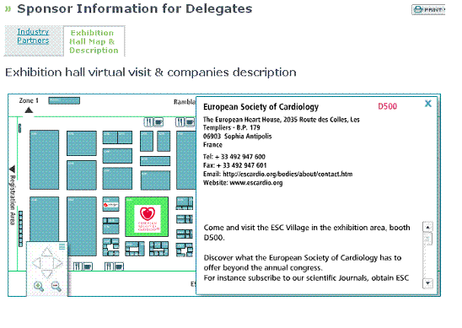
*Please email the logo files to exhibition@escardio.org in 2 sizes (one for listing, one for detailed description).
- large logo: 100x100 pixel (logo centered)
- small logo: 100x20 pixel (logo centered)

Thank you for sending this completed form to

exhibition@escardio.org

To see other important dates, get a copy of the Guidelines for Industry Participation or download technical information, order forms & hall plans, follow this link:
http://www.escexhibition.org/Munich08/default.aspx

