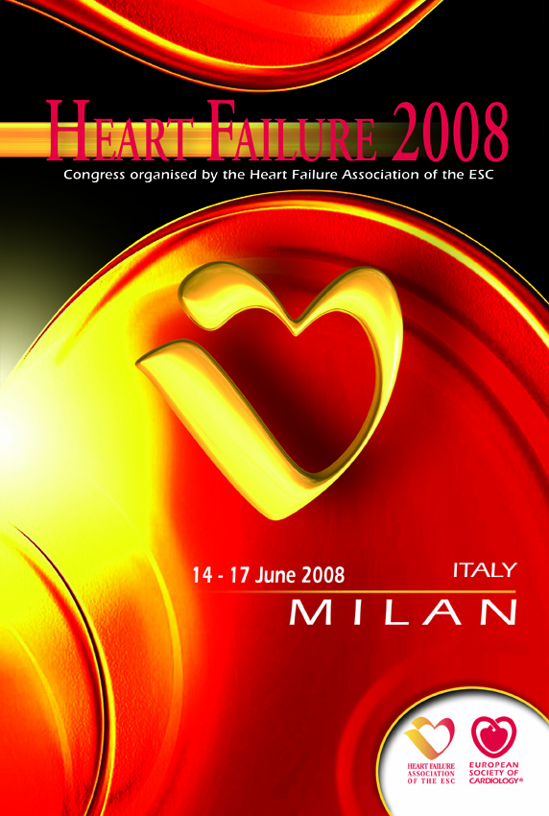 Heart Failure 2008
Exhibitor Information
Deadline: 14 March 2008

Company/Product Description

Complete your company address & descriptive text as you would like to see it appear in official publications e.g:
- Online at www.escardio.org for company & product descriptions
- Event Final Programme & other documents for your company name & address.
Note the description is limited to 50 words format is plain / bold text.
Company name & stand number will be wholly capitalised, other lines in sentence case.

COMPANY NAME*

STAND NUMBER

Address Line 1
Address Line 2
Postcode & City
Country

Tel: + (Intnl. dialing code) / Fax: + (Intnl. dialing code)

Email: Web: (url here)

Company & Product Description (50 words max, no special characters except ®, © and ™)

*Please note that the company name provided on this form will appear on all printed and digital media

Thank you for sending this completed form to
hfexhibition@escardio.org

To see other important dates, get a copy of the Guidelines for Industry Participation or download technical information, order forms & hall plans, follow this link:
http://www.escexhibition.org/HeartFailure2008/default.aspx

