Heart Failure 2007
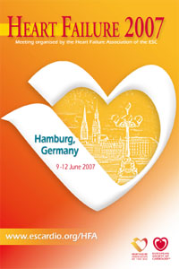
Exhibitor Information
Deadline 16 March 2007

Company & Product Descriptions

Complete your company address & descriptive text as you would like to see it appear in official publications e.g:
- Online at www.escardio.org for company & product descriptions and the
- Event Final Programme & other documents for your company name & address.
Note the description is limited to 50 words format is plain / bold text.
Company name & stand number will be wholly capitalised, other lines in sentence case.

COMPANY NAME*

STAND NUMBER

Address Line 1
Address Line 2
Postcode & City
Country

Tel: + (Intnl. dialing code) / Fax: + (Intnl. dialing code)

Email: Web: (url here)

Company & Product Description (50 words max, no special characters except ®, © and ™)

*Please note that the company name provided on this form will appear on all printed and digital media

Heart Failure 2007
Exhibitor Information
Deadline 16 March 2007

NEW this year!

Add you company logo to the Virtual Exhibition Map Listing
Price is € 500

Yes* No

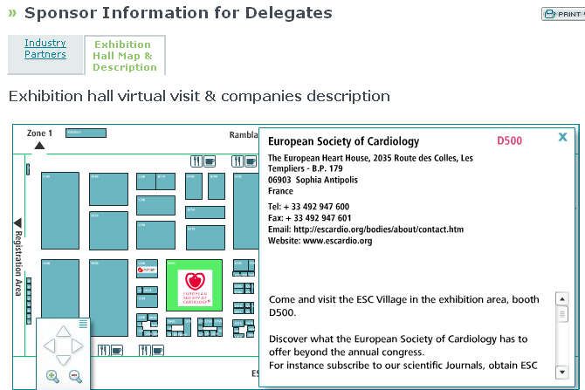

*Please email the logo files to exhibition@escardio.org in 2 sizes (one for listing, one for detailed description):
- large logo: 100x100 pixel (logo centered),
- small logo: 100x20 pixel (logo centered)

Thank you for sending this completed form to

exhibition@escardio.org

To see other important dates, get a copy of the Guidelines for Industry Participation or download technical information, order forms & hall plans, follow this link:
http://www.escexhibition.org/HeartFailure2007/default.aspx

