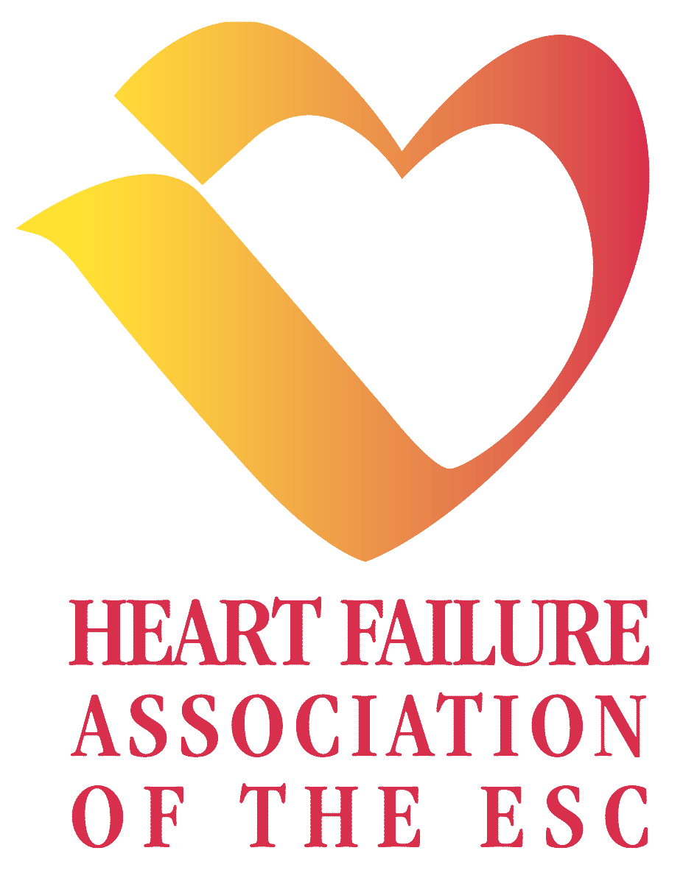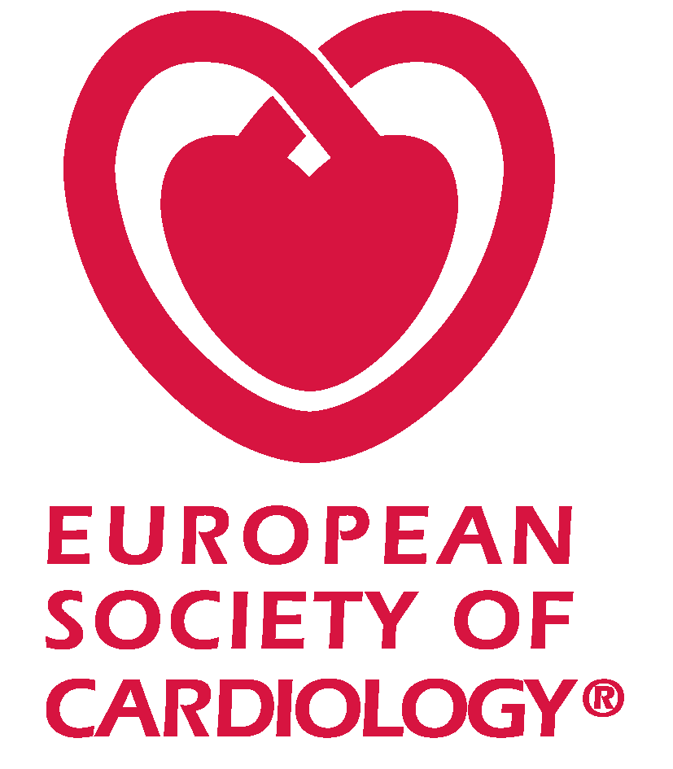

GRAPHIC CHART HEART FAILURE 2005

Usage of the Heart Failure Association of the ESC logo, Heart Failure 2005 logo and ESC logo is mandatory for all documents referring to Satellite Symposia (invitations, leaflets, banners…) and all promotional materials to be displayed during the meeting.

Header:

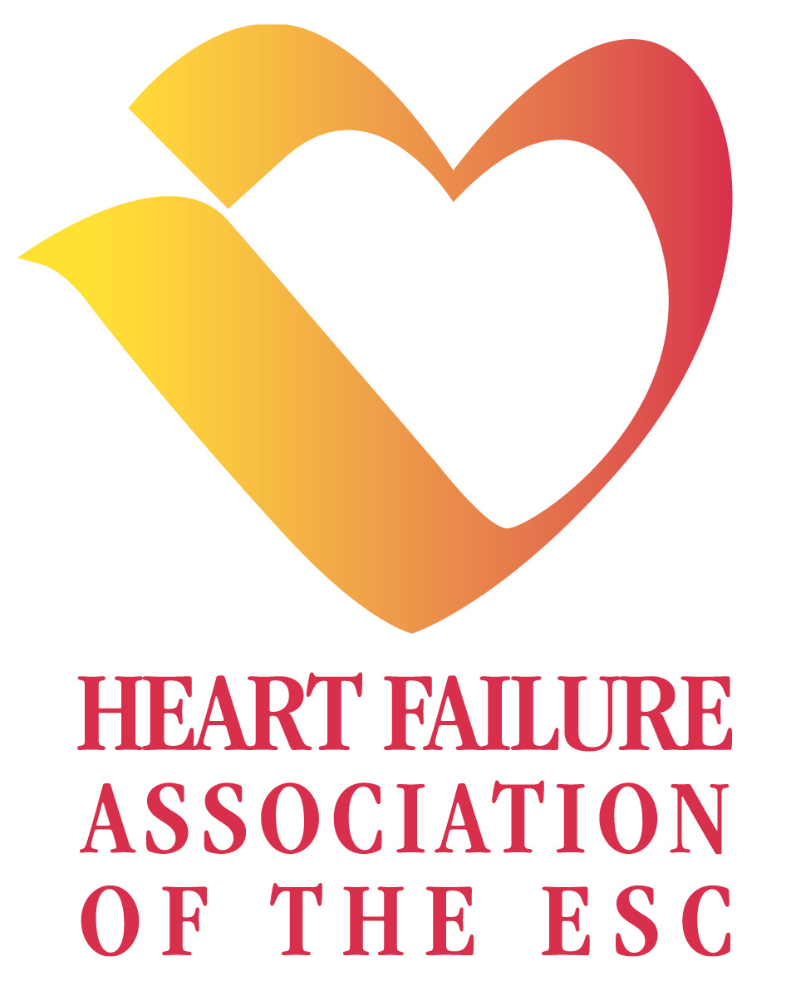
A Satellite Symposium held during the meeting

- Heart Failure Association of the ESC logo:

TYPOGRAPHY:
The logo typography is GARAMOND font

COLOURS:

The Heart Failure Association of the ESC logo must always be printed in its original colour

Pantone reference 4/C PROCESS

Red 193 CV Magenta 100%, Yellow 70%,

Black 10%

Pantone reference 4/C PROCESS

Yellow 109 CV Magenta 10%, Yellow 95%,

- Heart Failure 2005 logo:

TYPOGRAPHY:
The logo typography is GARAMOND font

COLOURS:

The Heart Failure 2005 logo must always be printed in its original colour

Pantone reference 4/C PROCESS

Red 193 CV Magenta 100%, Yellow 70%,

Black 10%

European Society of Cardiology logo:

TYPOGRAPHY:

The logo typography is ERAS DEMI font

COLOURS:

The ESC logo must always be printed in its original colour

Pantone reference 4/C PROCESS

Red 193 CV Magenta 100%, Yellow 70%,

Black 10%

- SENTENCES:

“A Satellite Symposium held during the meeting”,

TYPOGRAPHY: ERAS DEMI

COLOURS: Black 100%

POSSIBILITIES OF BACKGROUNDS FOR THE COMPLETE HEADER ARE THE SAME AS FOR THE ESC LOGO:

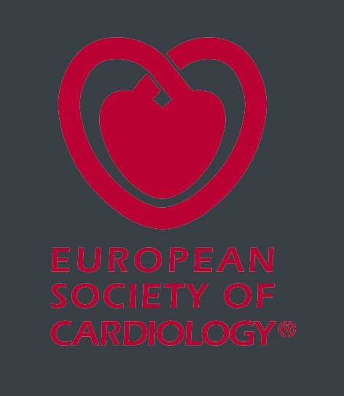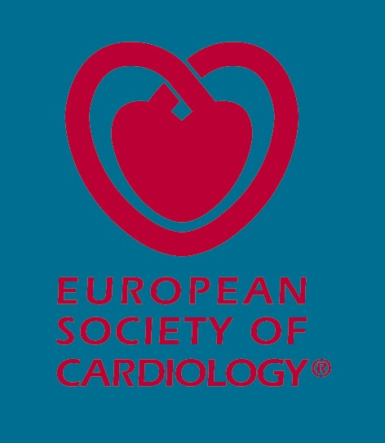

3 backgrounds: White / Red / Petrol Green

- ESC COLOURS :

Pantone reference 4/C PROCESS
Red 193 CV Magenta 100%, Yellow 70%,

Black 10%

Pantone reference 4/C PROCESS
Petrol Green 3155 CV Cyan 100%, Yellow 30%,
Black 30%

Pantone reference 4/C PROCESS
Grey 432 CV Cyan 25%, Black 80%

FOR FURTHER INFORMATION, PLEASE CONTACT:
Marketing, Membership & Communication Division
Isabelle Collin
Tel: + 33 4 92 94 86 61
Fax: +33 4 92 94 86 69
E-mail: icollin@escardio.org

