
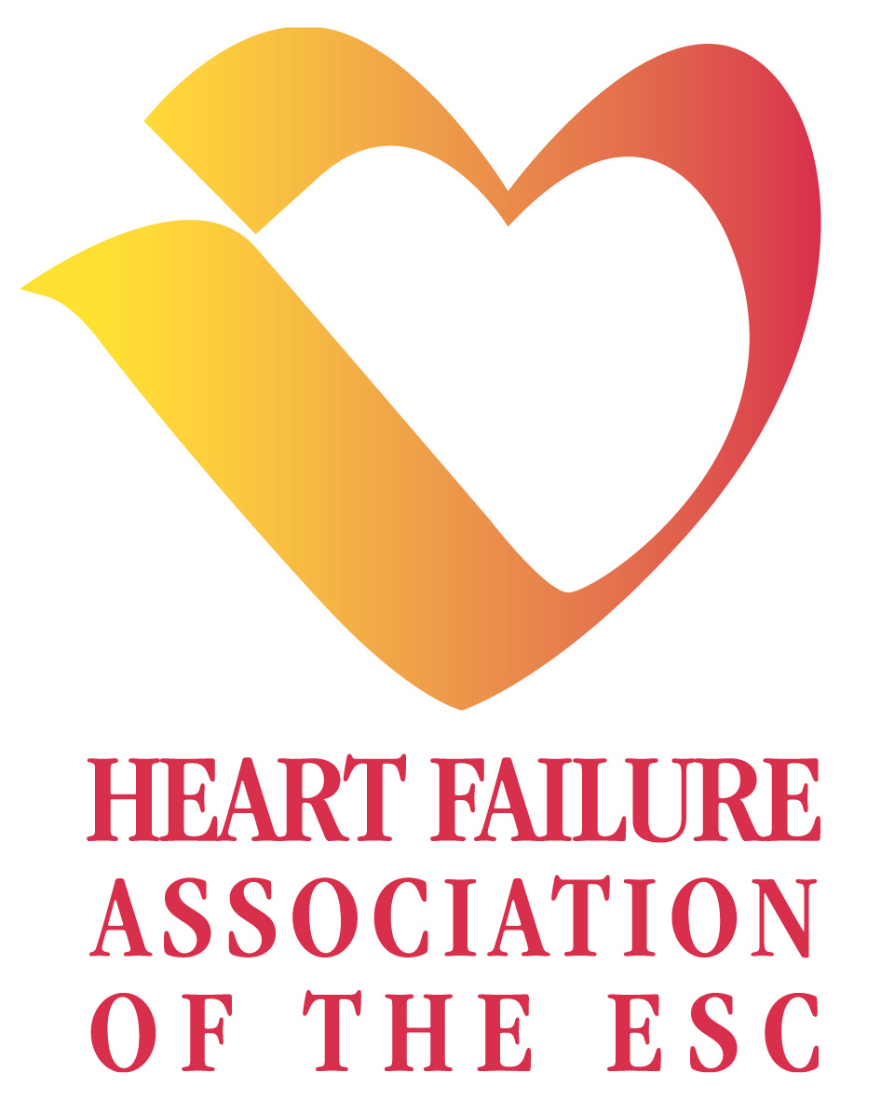
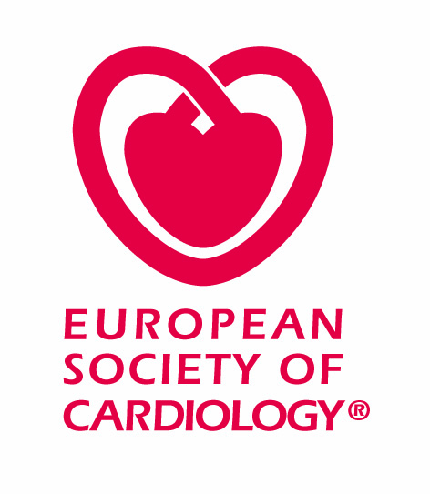
GIVE AWAY & STAND ACTIVITY AKNOWLEDGEMENT FORM
Please note that this form is to be returned to the ESC before April 17, 2009.
Thank you for sending this completed form to HFexhibition@escardio.org

1. | Please type the company name & details:
Company Name:
Contact Person:
Tel:
Email:

2. | Please list & describe your intended Give Away(s):
Item(s) | Description(s) | Retail value
 |  | €
 |  | €
 |  | €
 |  | €
 |  | €
 |  | €
 |  | €
 |  | €
 |  | €

3. Please give details of any intended quizzes/stand attractions:

-Please add drawing and/or picture of the give away(s).
-Remember that the maximum retail value of each give away must not exceed € 10 and € 50 for a “medical information carrier”such as DVD, slide set or USB memory device containing genuine scientific educational material (not purely product based info)
You have personal data which is, according to the Law on data processing and Civil Liberties 78-17 of 6 January 1978, registered with the ESC.
You have the absolute right to access, amend and oppose any use of this personal data by contacting (in writing) the ESC National Society and Member Relations at the address mentioned below. Unless otherwise informed, the ESC may send you information about its activities from time to time.

Exhibition & Congress Services Dept.
European Society of Cardiology
2035 Route des Colles
Les Templiers - BP 179
06 903 Sophia Antipolis
France

