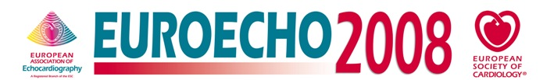
Exhibitor Information

Deadline 26 September 2008

Final Progamme / Company & Product Descriptions

Complete your company address & descriptive text as you would like to see it appear on the EUROECHO 2008 Final Programme.
Note the description is limited to 100 words, format is plain / bold text. Company name & stand number will be wholly capitalised, other lines in title case.

COMPANY NAME:
(Please provide the company name as you wish it to be listed in all printed and formal documents, i.e. the Final Programme)

STAND NUMBER:

Address Line 1
Address Line 2
Postcode & City
Country

Tel: + (Intnl. dialing code)
Fax: + (Intnl. dialing code)

Email: Web: (url here)

Company and Product Description:
(100 words max, no special characters except ®, © and ™)

Thank you for sending this completed form to

EEexhibition@escardio.org

Deadline 26 September 2008

To see other important dates, get a copy of the Guidelines for Industry Participation or download technical information, order forms & hall plans, follow this link:

www.escexhibition.org/Euroecho2008

