EUROPACE Badge Reader:

One of the most important decisions you make in your planning for exhibiting at
EUROPACE is how you record a prospective customer’s information.
PcLoc Events propose a small, handheld badge reader that works just
like a laser pointer. This unit stores all your leads in its internal memory,
giving you a convenient portable, wireless form of lead storage that you
can take with you wherever you go during the conference. Walk around your stand,
scan participants, speakers or take contact information at satellite symposium.
Simply return the Badge Reader at the end of the event and receive all your leads
in an E-mail. Action code cards included.

UPcLoc Events services on site:
- PcLoc Events team will be at the support desk from the 23rd of June 2007.
- You will meet us at the support desk every day and we will collect your data from your reader.
- A statistic report of use for each badge reader will be given to you (with date, stand n°, number of readings done for the day).
- PcLoc Events team will also be on site during exhibition and satellite sessions.
- If your reader is full, it beeps and a red light starts to flash. You need to contact us and we will come to collect data from your reader. A mobile number to be used during the event will be given to you.
- Your complete data file will be sent to the email address requested on your order form 10 days after the event.
UOptions:
-To ensure separation of data, each badge reader can be ordered with a specific name (see order form):
when several badges readers are used within the same company or when used for satellite sessions.
-For satellite sessions, as soon as the session is over, meet us at the support desk and we will collect your data
from your reader.
-To store qualifying information, you can set up personalised action codes (action code cards provided).
UOrder:
-Deadlines for ordering:
  - Orders will be preferably taken until 8th of June but they will still be accepted on site.
-Cancellation conditions per unit:
  - Until the 8th of June: free.
  - From date to 9th to 15th of June: charge of 50% per unit cancelled.
  - After the 15th of June: charge of 100% per unit cancelled.

UDeposit:U 600€ will be charged for any lost or broken badge reader and 150€ for any lost or broken charger.
Credit card details or a cheque of 750€ will be required as a guarantee during the Congress.

UDelivery / Picking Up:U from the 23rd of June 10am at the PcLoc Events desk.

UReturn:U when you have finished using the reader, barcodes readers must be returned to PcLoc Events desk.

UComments:U should be made on line and until 60 days after returning the badge reader.

Please note that you should charge the badge reader with the battery charger provided every night after use.

The Badge Reader Support Desk will be located in the Registration Area



EUROPACE

Lisbon
24th – 27th June 2007

September 2004

EUROPACE BADGE READERS

PcLoc Events :  22 avenue Galliéni  06 000 Nice-France | Contact :  Marie Lecomte | Tel : +33 (0)4 97 08 14 14  Fax : +33 (0)4 97 08 14 75  email: info@pclocevents.com

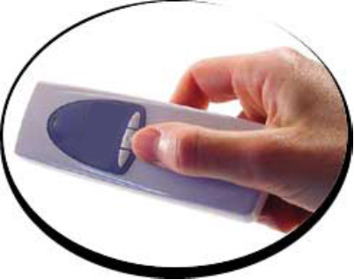
I have read and agree to these terms:

Company Stamp

