SPECIAL EQUIPMENT – REQUEST

Heart Failure 2015 - Sevilla
Exhibitor ..................................................
Hall / Stand ..................................................

Standbuilder ..................................................
Contact ..................................................
Mobile ..................................................

Invoice to:
Company ....................................................
address ....................................................
address ....................................................
ZIP / Town ....................................................
Contact ....................................................
Phone ....................................................
e-mail ....................................................
VAT – No. ....................................................

Please send this form completed back to:

e-mail Stefan.Grunwaldt@Fairexx.com or Fax +49 (0) 30 – 4403 47 79

Material Lift (Genie handycrafted) Working height 7 m
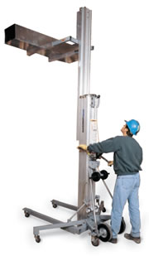
(sample)

BUILD – UP from ...................................... (Day/Time) to .................................... (Day/Time) ...... pcs.
from ...................................... (Day/Time) to .................................... (Day/Time) ...... pcs.

DISMANTLING from ...................................... (Day/Time) to .................................... (Day/Time) ...... pcs. from ...................................... (Day/Time) to .................................... (Day/Time) ...... pcs.

BUILD – UP from ...................................... (Day/Time) to .................................... (Day/Time) ...... pcs.
from ...................................... (Day/Time) to .................................... (Day/Time) ...... pcs.

DISMANTLING from ...................................... (Day/Time) to .................................... (Day/Time) ...... pcs. from ...................................... (Day/Time) to .................................... (Day/Time) ...... pcs.
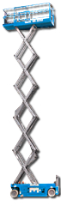
(sample)

Scissor Lift Working height 8 m

Minimum rental charges per item: 1 day/ please order minimum 2 days before renting/ 6% machinery insurance on total rental price / 19% VAT on total renting amount / other special equipment on request.
Business is undertaken subject to German Forwarders Standard Terms and Conditions (AdSp) latest edition, SLVS has signed by us. The conditions are available on request. In addition the fair and Exhibition Conditions are applicable. Court of law: District Court Berlin (HRB 10606B) / VAT DE813097138
Fairexx GmbH, Marienstrasse 28, 12207 Berlin/DE

................................................................ ....................................................................................... .................................................
Place / Date signature / name in blockletters company stamp

