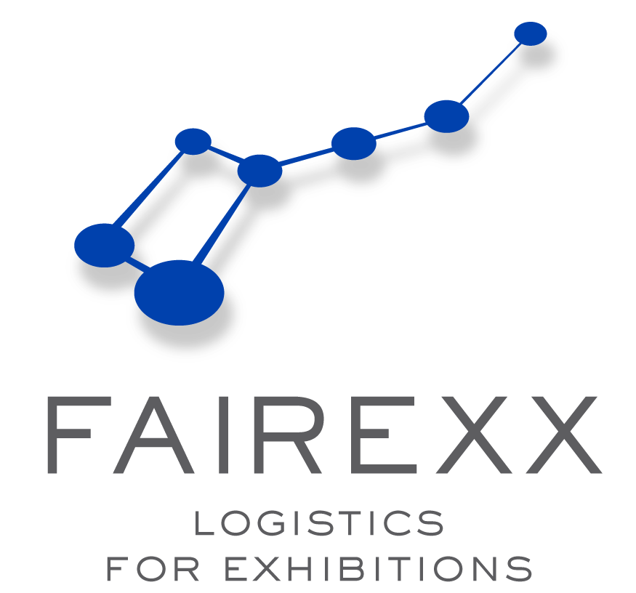
FAIREXX - LOGISTICS FOR EXHIBITIONS GMBH

Marienstrasse 28, 12207 Berlin / Germany
Phone : +49-30-44 03 47 13 / Fax : +49-30-44 03 47 79

Email : Stefan.Grunwaldt@fairexx.com

Lifting & Forwarding Tariff for : EUROECHO-IMAGING 2015

Venue : FIBES – Sevilla, Spain (2nd – 5th December 2015)

POS. | Lifting – DIRECT Handling ex/ONTO truck & DELIVERY TO/ex Stand : |  |  |  |  |  | EUR / €
1 | Direct offloading/reloading trucks directly to/from booth, working days  - lump-sum for full load (13,6 ldm / max. 12 tons)  - lump-sum for half load ( 7,0 ldm / max. 6 tons)  - smaller vehicles (M/M EUR 250,00 !) - per cbm |  |  |  |  |  | 1.450,00  800,00  60,00
POS . | Manipulation with empties & accessible storage : |  |  |  |  |  | EUR / €
2 | 2.1 Collection / storage/ Re-delivery of empty cases  from / to booth (M/M 3 cbm) - per cbm  2.2 Standbuilder tools - genies, ladders, etc – &  Priority empties (M/M 3 cbm) - per cbm  2.2 Full goods storage during the show on call - only on request ! |  |  |  |  |  | 75,00  105,00
POS . | Customs Clearance Formalities : |  |  |  |  |  | EUR / €
3 | Temporary or Final Import/Export Customs clearance on Proforma - per clearance  (incl. 1 customs tariff-no.)  - each other customs tariff-no. - per tariff-no |  |  |  |  |  | 275,00  35,00
4 | Closing of temporary import-file - per file |  |  |  |  |  | 75,00
5 | Attendance for customs examination – per shipment - per shpt./way |  |  |  |  |  | 75,00
6 | Import/Export customs clearance per Carnet ATA, each way - per ATA-Carnet |  |  |  |  |  | 275,00
7 | for temporary clearance: Customs Bond guarantee 5 % on CIF Value - but Minimum per shipment |  |  |  |  |  | 5 %  95,00
8 | Use of deferment account for VAT/Duty (M/M = EUR 65,00/p.clearance !)  Pre-financing fee for advanced payment of duties/taxes to Customs - per clearance |  |  |  |  |  | 15 %
POS . | Labour Hire for Working at Stand Only : |  |  |  |  |  | EUR / €
9 | Unskilled worker, workdays, per hour – (M/M = 4 hours/man) - per hour/man |  |  |  |  |  | 65,00
POS . | Transport & Handling Costs for AIRFREIGHT OR groupage ROADcargo: |  |  |  |  |  | EUR / €
10 | Transport from Munich-airport to venue FIBES-Sevilla - or vice versa  - per kgs (1 cbm = 333 kg) (Minimum = EUR 250,-/shpt.) - per kgs  (excl. any airline handling fee / storage charges !) |  |  |  |  |  | 2,50
11 | Transport from advanced german-warehouse up to venue - or vice versa  - per 100 kgs (1 cbm=333 kgs) (M/M per shipment = EUR 250,00) - per 100 kgs |  |  |  |  |  | 45,00
12 | from free Arrival venue up to delivered booth or vice versa  (M/M per shipment = EUR 195,00 !) - per 100 kgs |  |  |  |  |  | 25,00
POS . | Other Costs : |  |  |  |  |  | EUR / €
13 | Attendance / Service Charge - per shpt/way |  |  |  |  |  | 110,00
14 | Complusory warehouse insurance fee - per shpt/way |  |  |  |  |  | 45,00
POS . | Surcharges - Add to Items :
15 | Overtime Mo-Fr from 17:30h -20:00h | + | 50 %
16 | Night working Mo-Fr from 20:00h – 08:00h | + | 100 %
17 | Saturday | + | 100 %
18 | Sunday / Bank Holidays | + | 100 %
19 | Upper floor surcharge | + | 25 %
20 | 50% late arrival surcharges for all shipments arriving after the deadline as per our Manual !!
Charges are subject to local rate of VAT. Please supply your Vat Ident Number on our order form.
All charges for return shipments are according to above Inbound Tariff excluding handling of empties.
Any other services not covered by this tariff will be charged according to our expenses or by agreement.
All our business is exclusively transacted subject to the most recent edition of the German Forwarders' Standard Terms and Conditions (ADSp). According to § 23 ADSp, the legal liability for damage to goods as statet in § 431 HGB (German Commercial Code) is limited to 5 EUR/kg whilst in the care of a forwarder; to 2 SDR/kg (Special Drawing Rights) for multimodal transports incl.sea transports as well as to an additional 1million EUR or 2million EUR per damage or event or else 2 SDR/kg depending on which amount is higher.

