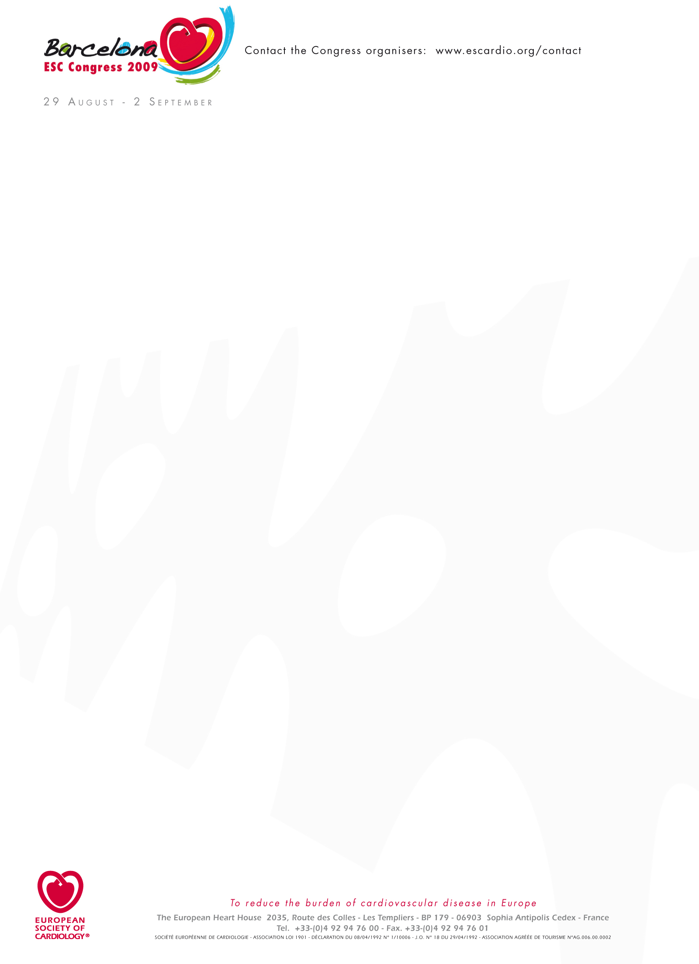
The duration of your Information Screen advertisement is 30". We remind you that our advertising policy remains unchanged: no product names, identifying product logos, misleading names that could be perceived as product names, or registered trademarks will be allowed. (See our Guidelines for Industry Participation for the ESC Congress 2009, pg 45). We ask you to follow scrupulously the technical specifications below.

1. Hall information System:
Resolution = 1024 x 768
Format = 4/3

2. Room information System:
Resolution = 1360 x 768
Format = 16/9
Size = 50 inches
Brand = Panasonic TH50PH9

Artwork Specifications & limitations.
• Pictures or logos must be provided with the highest resolution (mini = 72 DPI).
• No animations within Power Point will be allowed
• NO video clips
• Flash files ONLY in FLA, 30 frames per seconds, No files longer than 30 seconds

 | File Type | Sizes 4/3 | Sizes 16/9
Pictures | All files types | 1024 * 768 | 1360 * 768
PowerPoint | .ppt | 25.4 * 19.05 | 20.4 * 11.3
Flash | .fla (only)  30 frames per seconds  No animation longer than 30 seconds | 1024*768 | 1360 * 768
PDF | .pdf | 1024*768 | 1360 * 768
Texts | .txt or .doc | 1024*768 | 1360 * 768

Deadlines
- Deadline to send in to approve your artwork July 27
- Deadline to send in your finalised Information Screens July 31

Please note, your files should be sent to Sponsorship@escardio.org for approval. Once we have approved the content , the finalised versions will be sent to our A/V department for verification of the formats, resolutions and all of the technical aspects of your advertisement. We will get back to you with final approval from them.

